5.29:
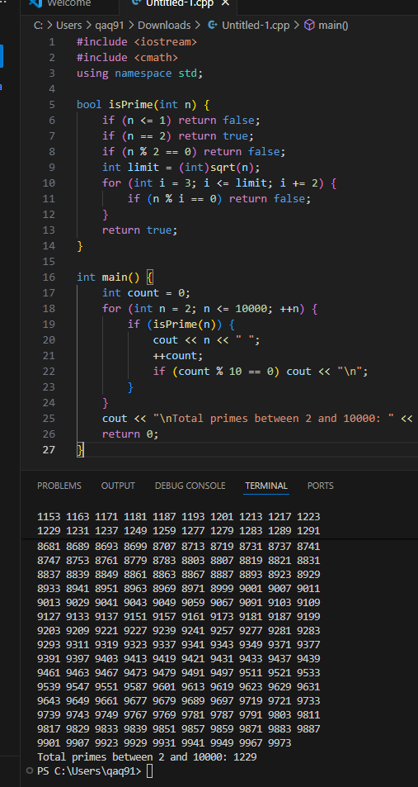
#include <iostream>
#include <cmath>
using namespace std;

bool isPrime(int n) {
if (n <= 1) return false;
if (n == 2) return true;
if (n % 2 == 0) return false;
int limit = (int)sqrt(n);
for (int i = 3; i <= limit; i += 2) {
if (n % i == 0) return false;
}
return true;
}

int main() {
int count = 0;
for (int n = 2; n <= 10000; ++n) {
if (isPrime(n)) {
cout << n << " ";
++count;
if (count % 10 == 0) cout << "\n";
}
}
cout << "\nTotal primes between 2 and 10000: " << count << endl;
return 0;
}
5.31:
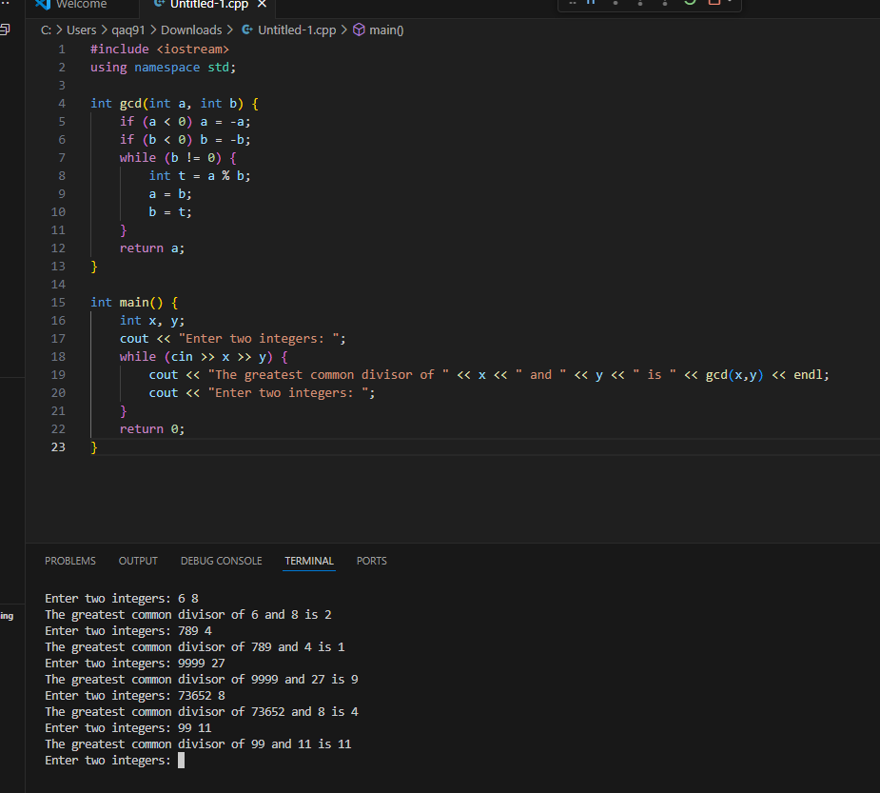
#include <iostream>
using namespace std;

int gcd(int a, int b) {
if (a < 0) a = -a;
if (b < 0) b = -b;
while (b != 0) {
int t = a % b;
a = b;
b = t;
}
return a;
}

int main() {
int x, y;
cout << "Enter two integers: ";
while (cin >> x >> y) {
cout << "The greatest common divisor of " << x << " and " << y << " is " << gcd(x,y) << endl;
cout << "Enter two integers: ";
}
return 0;
}
5.34
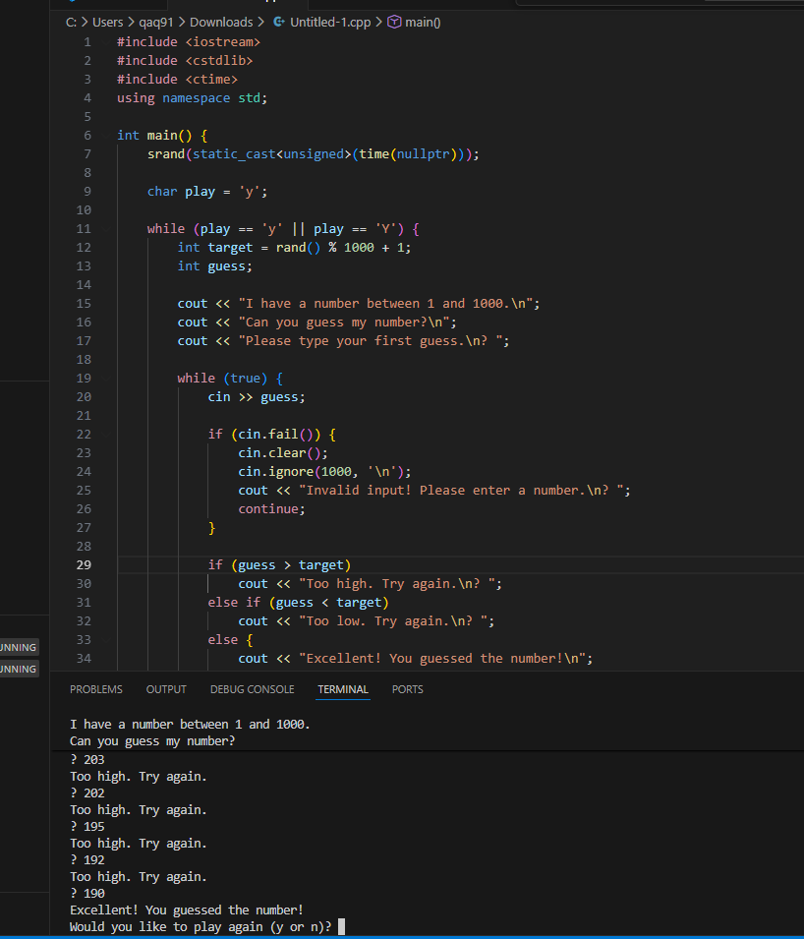
#include <iostream>
#include <cstdlib>
#include <ctime>
using namespace std;

int main() {
srand(static_cast<unsigned>(time(nullptr)));

char play = 'y';

while (play == 'y' || play == 'Y') {
int target = rand() % 1000 + 1;
int guess;

cout << "I have a number between 1 and 1000.\n";
cout << "Can you guess my number?\n";
cout << "Please type your first guess.\n? ";

while (true) {
cin >> guess;

if (cin.fail()) {
cin.clear();
cin.ignore(1000, '\n');
cout << "Invalid input! Please enter a number.\n? ";
continue;
}

if (guess > target)
cout << "Too high. Try again.\n? ";
else if (guess < target)
cout << "Too low. Try again.\n? ";
else {
cout << "Excellent! You guessed the number!\n";
break;
}
}

cout << "Would you like to play again (y or n)? ";
cin >> play;
}

return 0;
}

